LABORATORY # 08

Amplification of a Signal at Low/High Frequencies Using BJTs

We have already discussed introduction in Lab # 7. Let starts with circuit.
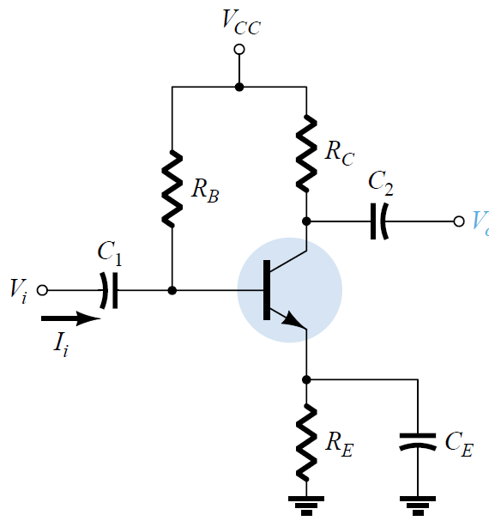
Figure 8.1 Common Collector Circuit
- Analyze the effect of Capacitor (C1, C2 and Ce) using 3.3uF, 1.0uF and 470uF. For each value of capacitor, apply the input signal with V=100mVpp at given range of frequencies (see Table 8.1) to the given circuit as shown in Fig. 8.1. Evaluate the behavior of an input signal with npn type BJT (2N3903/MPSA42). Use R_{B} = 15KΩ, R_{C}=1KΩ, R_{E}=1.5KΩ and V_{CC}=16V.
- Repeat part 1 for Vin=1Vpp
Procedure:
- Build the circuit as shown in Figure 8.1 in Multisim and amplify the input signal at given frequencies (Low/High) using BJT (2N3903/MPSA42).
- Build the circuit as shown in Figure 8.1 in Lab and amplify the input signal at given frequencies (Low/High) using BJT (2N3903/MPSA42).
- Complete Table 8.1 with your Multisim and experimental results.
- Attach input and output waveforms for both Multisim and experimental results.
- Discuss results in conclusion section. Analyze in terms of low/high value of capacitors
- Compare and discuss your results at Vin=100mV with Vin=1.0V.
- Compare amplification of a signal using BJT with respect to Op-Amp 741 (Lab 2).
- Draw the bandwidth graph based on your lab results for Vin=100mV and 1V.
Table 8.1
Frequency | Vout | Voltage Gain
10
30
60
100
200
500
1 KHz
2 kHz
5 KHz
10 KHz
15 KHz
20 KHz
50 KHz
75 KHz
100 KHz
150 KHz
200 KHz
500 KHz
750 KHz
1 MHz
1.5 MHz
2.0 MHz

Two exemplary circuits are shown below for reference purpose only.

